APS106: Getting Started with Jupyter

Notebook on macOS

# Prerequisite: Python is installed on your computer

Follow the instructions included in the Wing101 installation guide to install Python.

# Step 1: Install Jupyter Notebook

1. Open your launchpad or your applications folder
2. Search for the “terminal” application and click on the terminal icon

1. To install Jupyter notebook type “pip3 install notebook” into the terminal and press enter. Note: pip is the standard package manager for Python and with a minimum Python version of 3.4, pip is installed by default.

1. Jupyter notebook will begin to install
2. Wait a few minutes while Notebook installs, once the terminal stops executing you have installed Notebook! Hooray!

# Step 2: Launch Jupyter Notebook

1. A picture containing text

   Description automatically generated From the terminal enter “jupyter notebook” and press enter
2. Notebook Dashboard will open in your default browser.

* In Notebook Dashboard, you will see a list of the notebooks, files, and subdirectories in the directory where the notebook server was started.
* Notebook was opened from my user directory (which contains all my Documents, Downloads, Movies, etc. subfolders), so that’s why you see existing folders. You can navigate to wherever you want to create a new file (perhaps your APS106 folder) from here.

1. page3image61970048Text

   Description automatically generated If Notebook does not open in your browser, you can copy and paste one of the URLs listed in the terminal:
2. Make sure to leave the terminal open while using Notebook, as it used to run the Notebook Server.

# Step 3: Create a new Notebook

1. From the Notebook Dashboard click New → Python3

page3image61970240

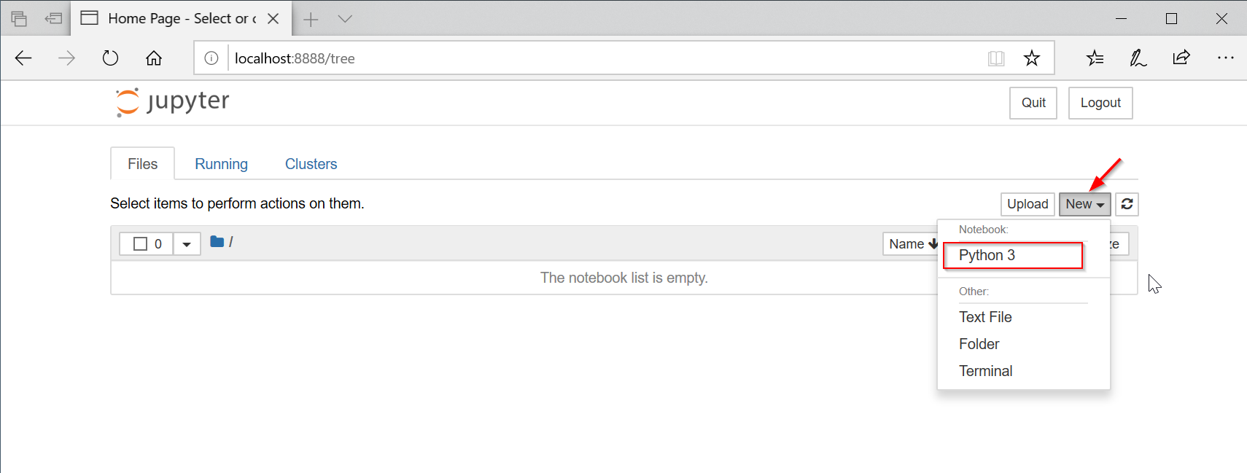

1. See a blank Notebook open:

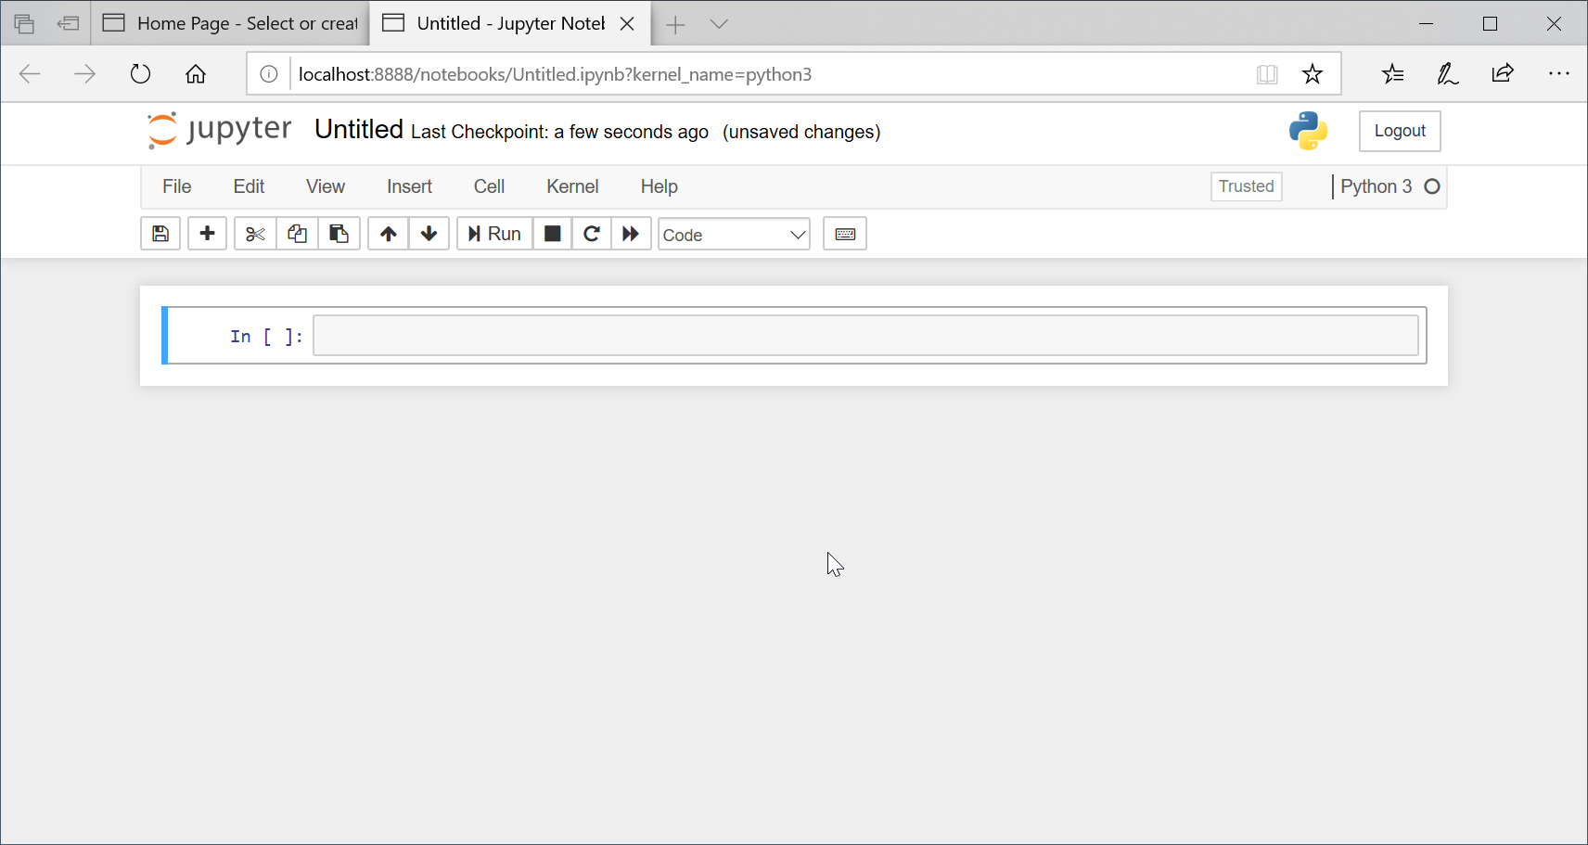

1. For a quick tour of Notebook, click “Help” → “User Interface Tour”

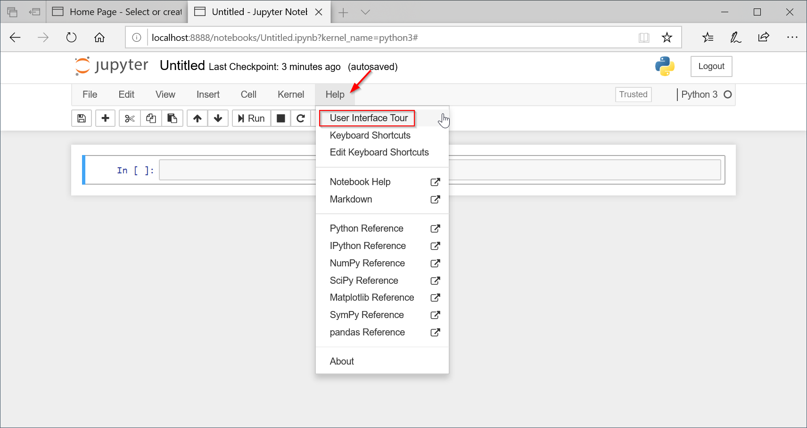

1. To rename your Notebook, click on “Untitled” at the top of the page and rename your Notebook

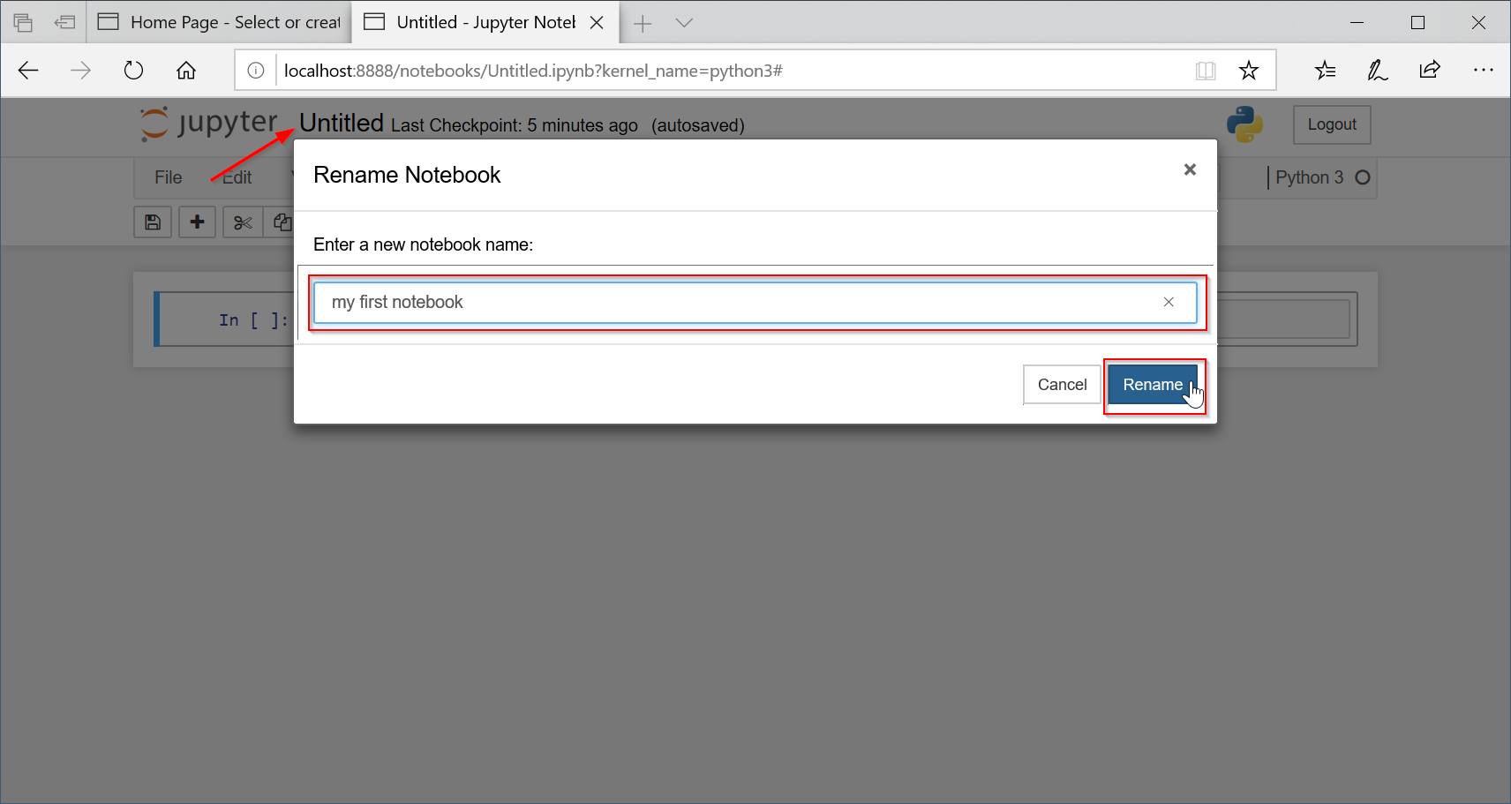

# Step 4: Add Code to your Notebook

* 1. Press Enter or click on the first cell to enter Edit Mode and begin editing your Notebook

page5image61988736

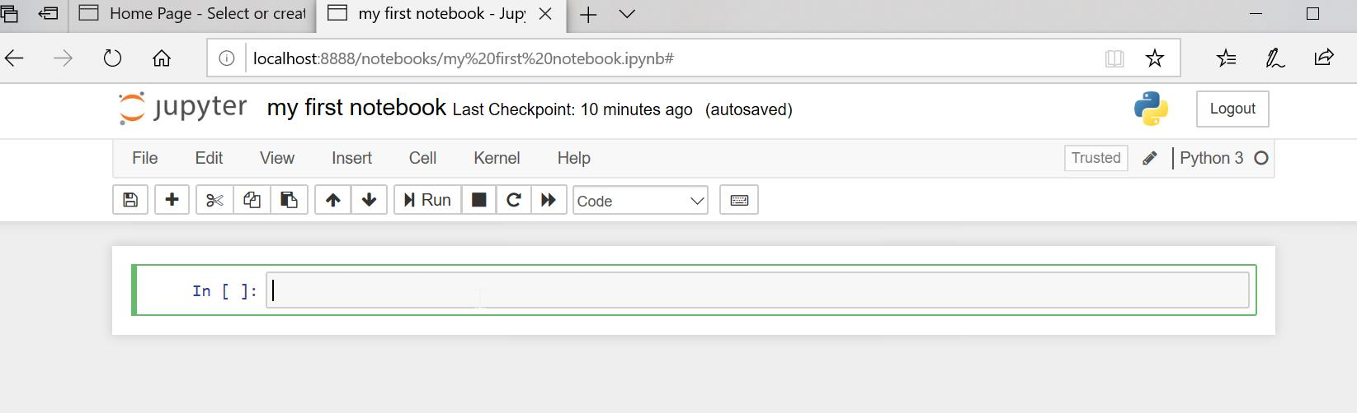

* 1. Add in code: print('Hello World!')

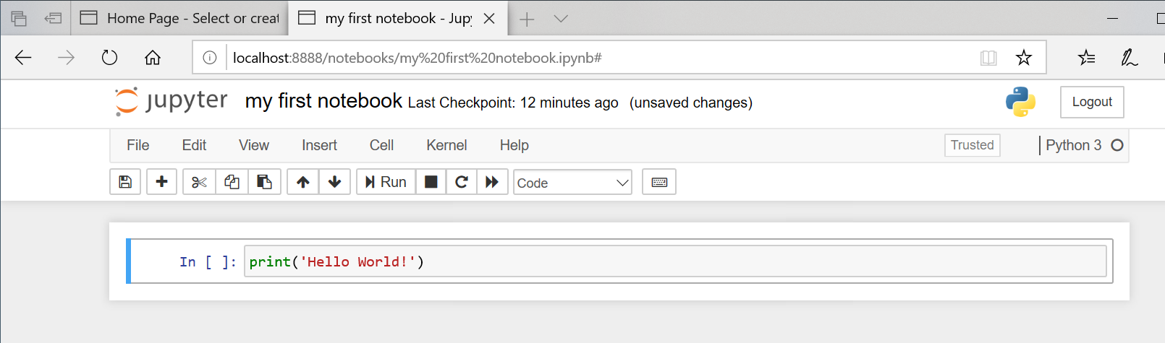

* 1. To run this code, click “Cell” → “Run Cells”

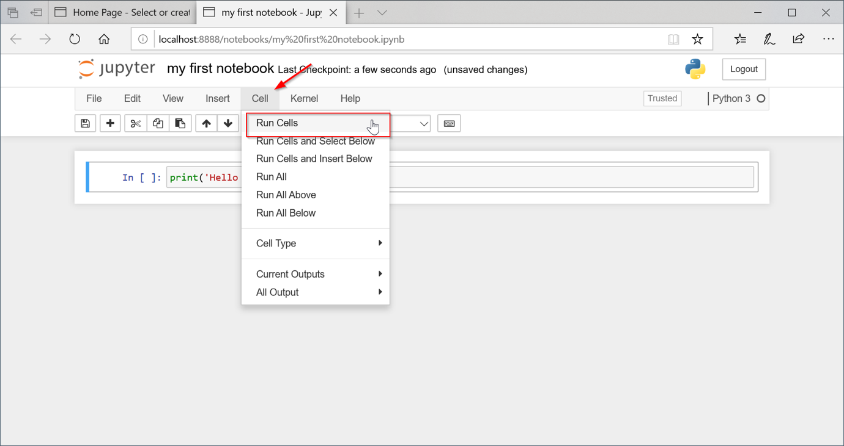

Output:

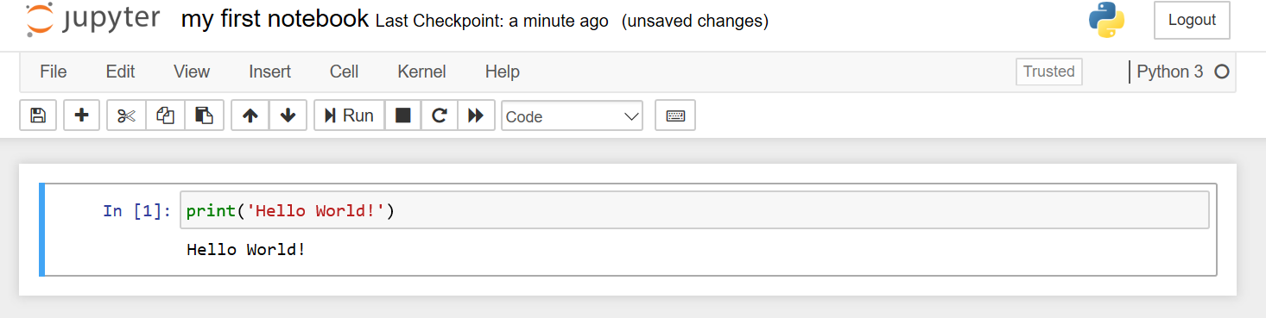

* 1. To run the code and an insert a new cell below, click “Cells” → “Run Cells and Insert Below”

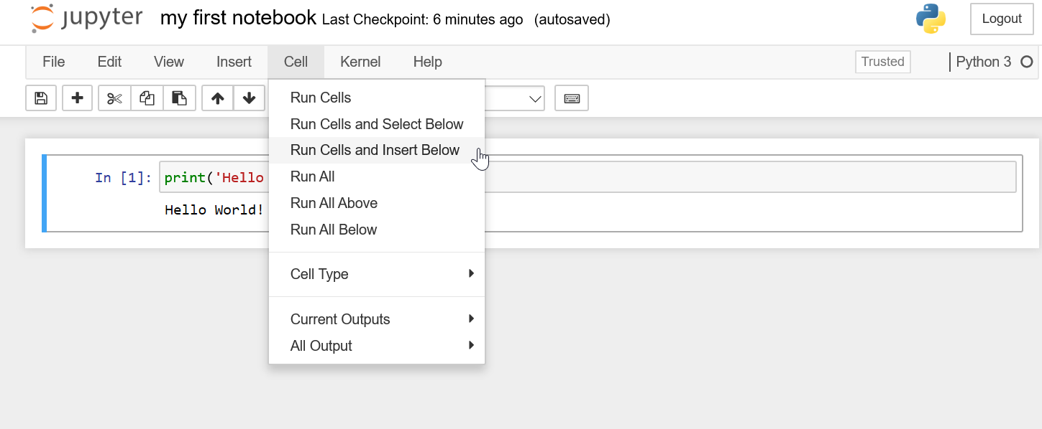

See how a new cell was inserted below:

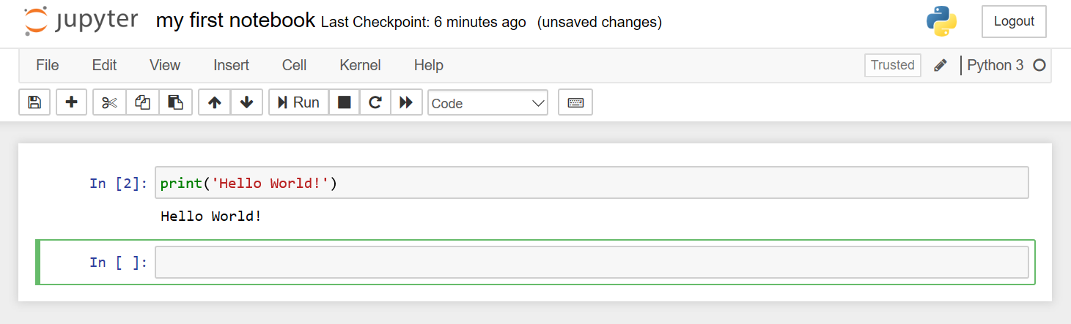

* 1. To run all the cells in your Notebook, click “Cell” → “Run All”

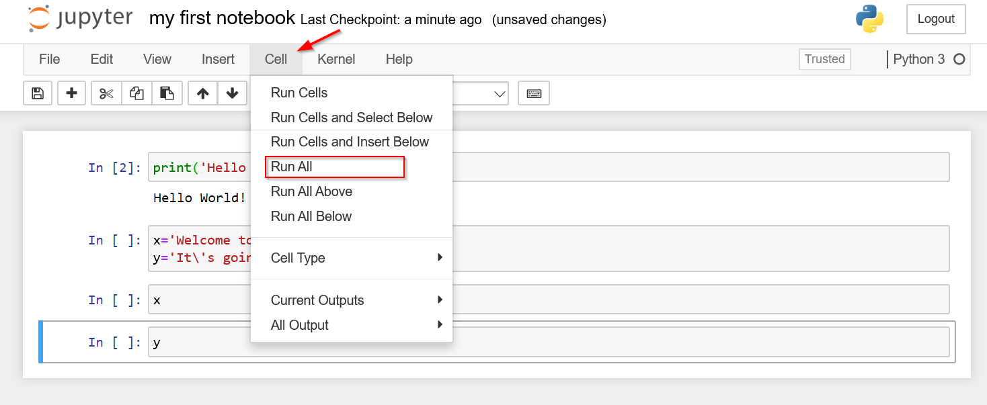

Output:

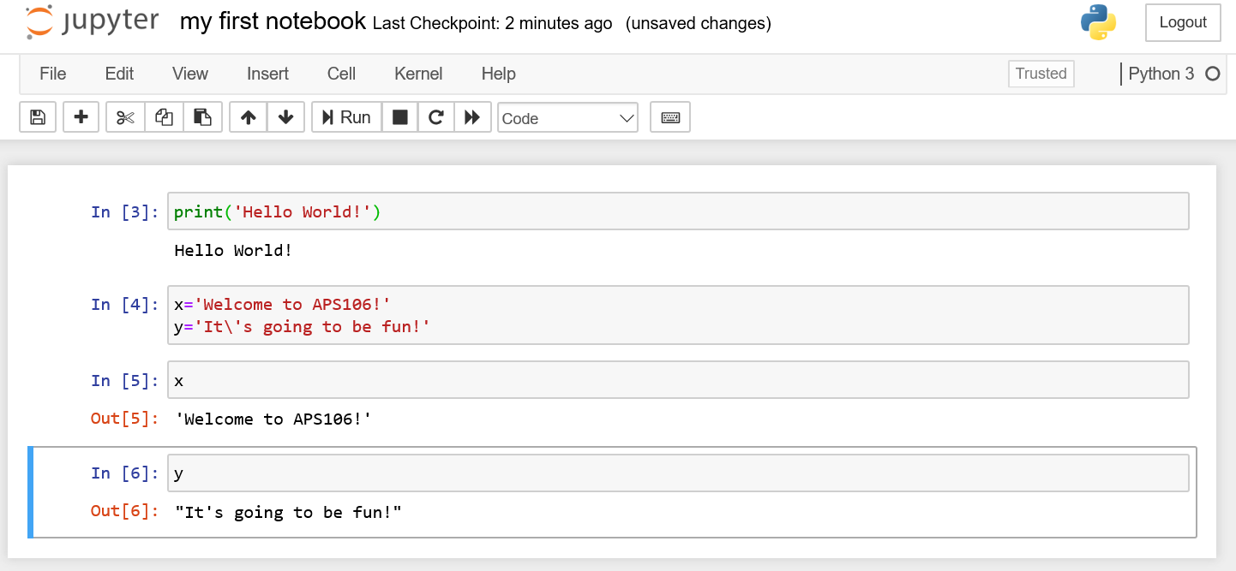

# Step 5: Add Markdown Cells to your Notebook

1. Text can be added into Jupyter using Markdown cells.
2. To add in a markdown cell, insert a new cell by clicking “Insert” → “Insert Cell Above” or “Insert Cell Below”

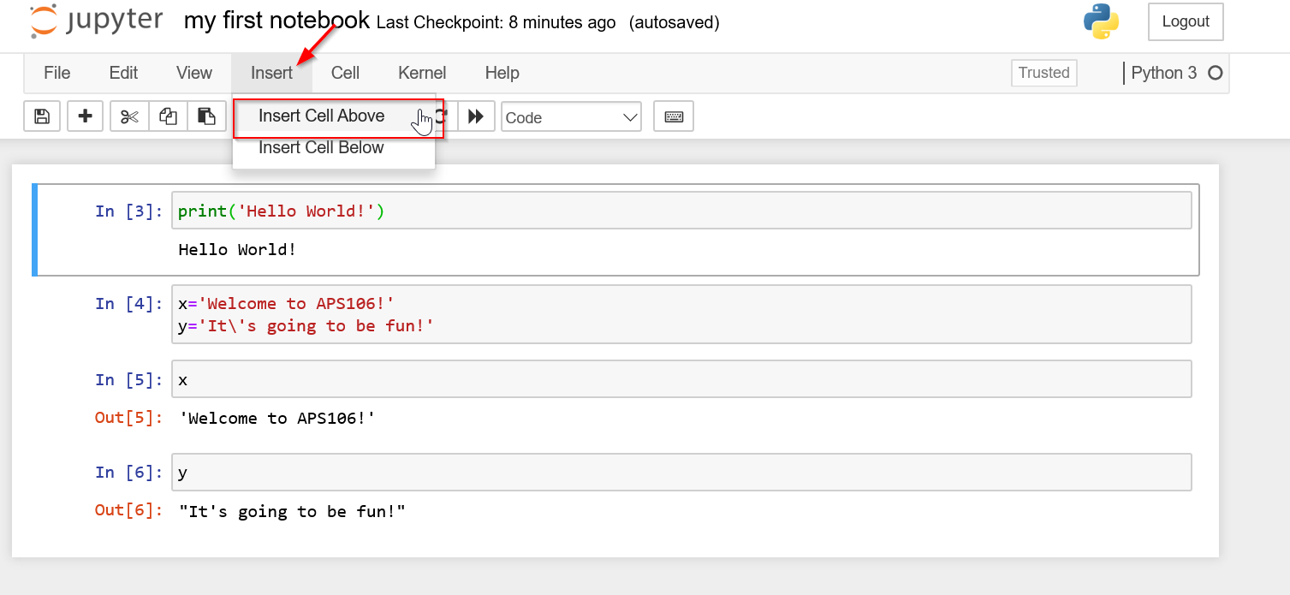

1. Once a cell has been inserted, click “Cells” → “Cell Type” → “Markdown” to change it to a Markdown Cell

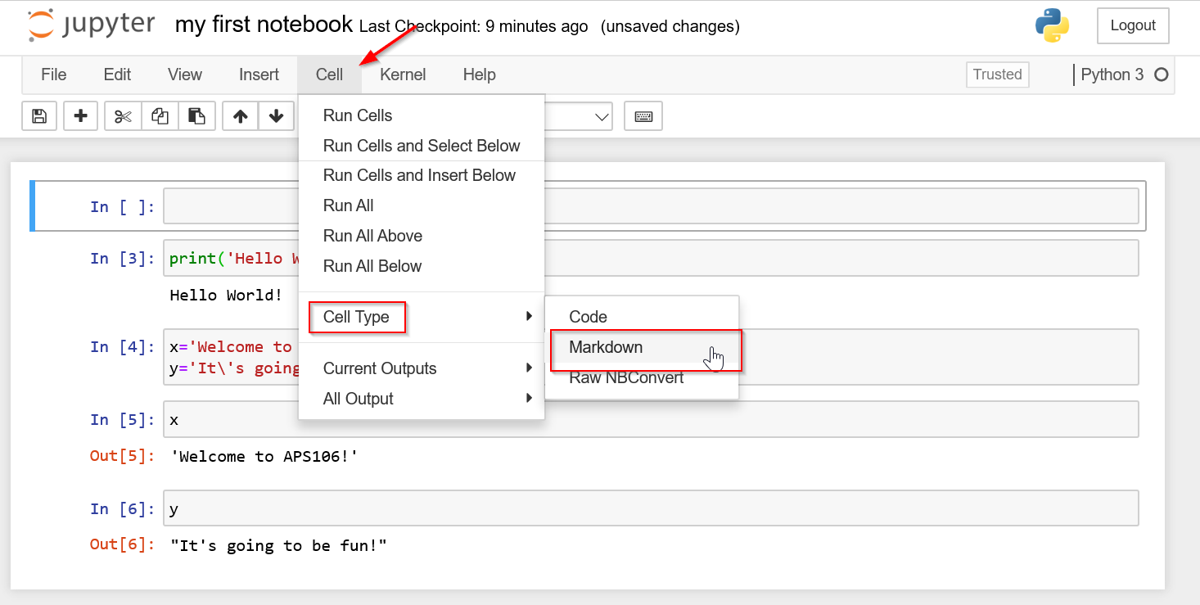

1. Now add in Markdown text. For details on markdown cells visit https://jupyter- notebook.readthedocs.io/en/stable/examples/Notebook/Working%20With%20Markdown%20Cells.html

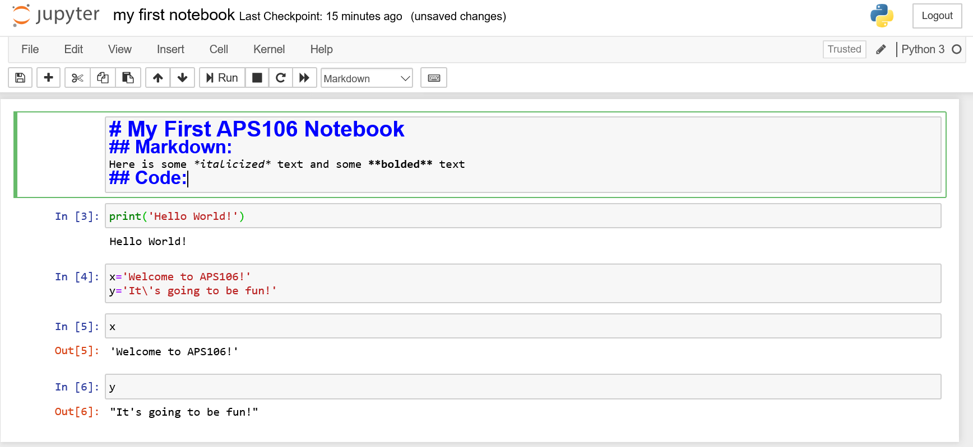

1. Run the Markdown cell

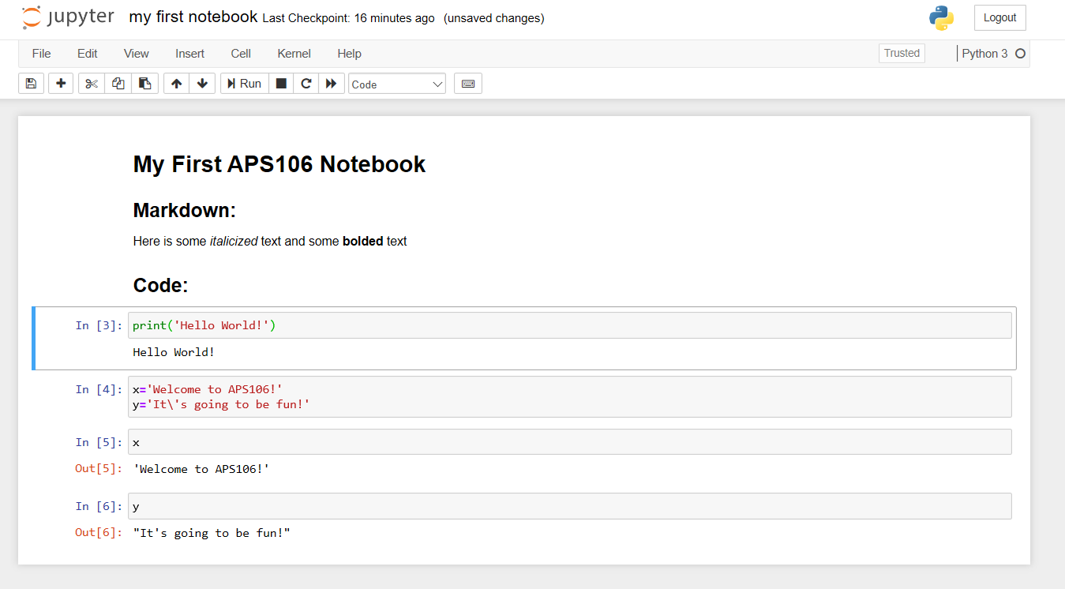

# Step 6: Edit an Existing Notebook

1. An existing notebook can be edited, by visiting the Notebook Dashboard and clicking the Notebook file to edit:

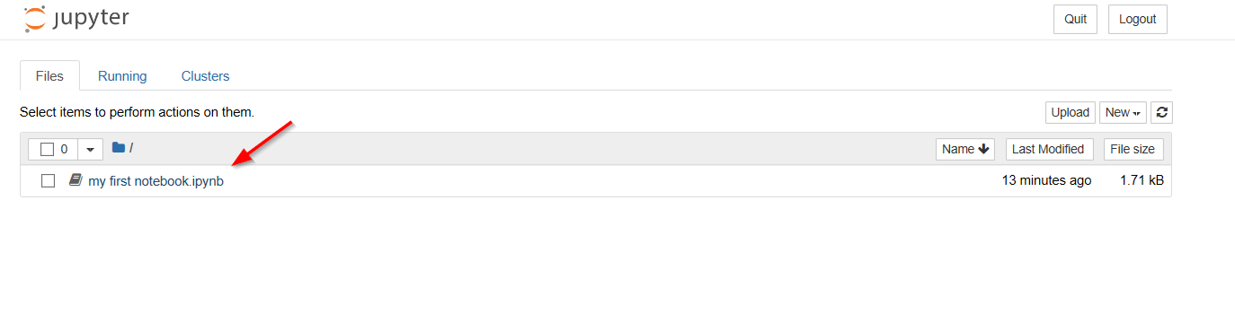

Congratulations! You have Jupyter Notebook installed and now know how to build your own! You’ve earned another picture of a programming cat.

